Brain Cancer Microarray Data
Weighted Gene Co-expression Network Analysis
R Tutorial

Steve Horvath, Bin Zhang, Jun Dong, Tova Fuller, Peter Langfelder
Correspondence: shorvath@mednet.ucla.edu, http://www.ph.ucla.edu/biostat/people/horvath.htm

This R tutorial describes how to carry out a gene co-expression network analysis with the R software.

Content of this tutorial
- 1) Gene Co-expression Network Construction. We show how to construct unweighted networks using hard thresholding and how to construct weighted networks using soft thresholding. We describe a criterion (scale free topology criterion) for choosing the threshold.
2) Module Definition Based on Average Linkage hierarchical clustering
with a tree cutting algorithm
3) Relating modules to prognostic significance for cancer survival time
Keywords: gene significance, module significance
4) Relating gene significance to intramodular connectivity.
5) Generalizing intramodular connectivity to all genes on the array.
Keyword: module eigengene based connectivity measure
6) Comparing weighted network results to unweighted network results
7) Studying the relationship between the clustering coefficicient and intramodular connectivity.

To cite this tutorial or the statistical methods please use the following 2 references
- Bin Zhang and Steve Horvath (2005) "A General Framework for Weighted Gene Co-Expression Network Analysis", Statistical Applications in Genetics and Molecular Biology: Vol. 4: No. 1, Article 17 Technical Report and software code at: www.genetics.ucla.edu/labs/horvath/CoexpressionNetwork.
- Horvath S, Zhang B, Carlson M, Lu KV, Zhu S, Felciano RM, Laurance MF, Zhao W, Shu, Q, Lee Y, Scheck AC, Liau LM, Wu H, Geschwind DH, Febbo PG, Kornblum HI, Cloughesy TF, Nelson SF, Mischel PS (2006) "Analysis of Oncogenic Signaling Networks in Glioblastoma Identifies ASPM as a Novel Molecular Target", PNAS | November 14, 2006 | vol. 103 | no. 46 | 17402-17407
The following theoretical reference explores the meaning of coexpression network analysis
  - Horvath S, Dong J (2008) Geometric Interpretation of Gene Co-Expression Network Analysis. PloS Computational Biology. 4(8): e1000117. PMID: 18704157
The WGCNA R package is described in
- Langfelder P, Horvath S (2008) WGCNA: an R package for Weighted Correlation Network Analysis. BMC Bioinformatics. 2008 Dec 29;9(1):559. PMID: 19114008
For the generalized topological overlap matrix as applied to unweighted networks see
- Yip A, Horvath S (2007) Gene network interconnectedness and the generalized topological overlap measure. BMC Bioinformatics 8:22

Microarray Data
The data and biological implications are described in Horvath et al 2006
The data were provided by Stan Nelson, who directs the UCLA Microarray core.
Expression of 22,215 probe sets (15,005 unique transcripts) was measured using Affymetrix HG-U133A microarrays, as previously described(16). Data files (cel) were uploaded into the dCHIP program ( http://www.dchip.org/) and normalized to the median intensity array. Complete gene expression for datasets 1 and 2 available at:
http://genetics.ucla.edu/labs/horvath/binzhang/Public/Networks/GBM_all_datasets.zip; ( dataset 1 = gbm55old_dchipALL_cox.xls; dataset 2 = bm65new_dchipAll_cox.xls. Quantification was performed using model-based expression and the perfect match minus mismatch method implemented in dCHIP.
More detailed descriptions and more detailed tutorials can be found at the following webpage:
http://www.genetics.ucla.edu/labs/horvath/CoexpressionNetwork/ASPMgene/

Methods Outline
The network construction is conceptually straightforward: nodes represent genes and nodes are
connected if the corresponding genes are significantly co-expressed across appropriately chosen tissue samples. Here we study networks that can be specified with the following adjacency matrix:
A=[a_{ij}] is symmetric with entries in [0,1]. By convention, the diagonal elements are assumed to be zero. For unweighted networks, the adjacency matrix contains binary information (connected=1, unconnected=0). In weighted networks the adjacency matrix contains weights.

The absolute value of the Pearson correlation between expression profiles of all pairs of genes was determined for the 8000 most varying non-redundant transcripts. Then, pioneering the use of a novel approach to the generation of a weighted gene coexpression networks, the Pearson correlation measure was transformed into a connection strength measure by using a power function (connection strength(i,j)=|correlation(i,j)|^β)(Zhang and Horvath 2005). The connectivity measure for each gene is the sum of the connection strengths (correlationβ) between that gene and all the other genes in the network. Gene expression networks, like virtually all types of biological networks, exhibit an approximate scale free topology. A linear regression model fitting index R2 between log p(k) and log(k) was used to determine how well a resulting network fit scale free topology for a range of values. The scale free topplogy criterion (Zhang and Horvath 2005) was used to determine the power,: specifically, a value of =6 was the lowest power that resulted in a scale free topology fit R^2 that was >0.9 (Supplementary Fig. 1).
We will discuss the choice of this power in great detail below and provide several arguments that this choice of power results in a biologically meaningful network.
Most biologists would be very suspicious of a gene co-expression network that does not satisfy scale-free topology at least approximately. Therefore, thresholds (or powers) that give rise to networks that do not satisfy approximate scale-free topology should not be considered.

Detection of hub genes:
To identify hub genes for the network, one may either consider the whole network connectivity (denoted by kTotal) or the intramodular connectivity (kWithin).
We find that intramodular connectivity is far more meaningful than whole network connectivity

Relating hub gene status to gene (prognostic) significance:
For each of the 55 glioblastoma samples patient survival information was available. Since some of the survival times were censored, we used a Cox proportional hazards model(21, 22) to define the prognostic significance of a gene by its univariate Cox regression p-value. More specifically we define the gene significance of each gene as minus log10 of the univariate Cox regression p-value.
Thus high values of the gene significance imply that the gene expression is a significant predictor of patient survival, see Mischel et al 2005.

Abstractly speaking, gene significance is any quantitative measure that specifies how biologically significant a gene is. One goal of network analysis is to relate the measure of gene significance (here –log10[Cox p-value]) to intramodular connectivity.

Unweighted networks, hard thresholding
Based on the expression data, the absolute pair-wise (Pearson) correlation coefficient between the expression profiles of each pair of genes is calculated. Then, a network with each node
representing one gene is constructed. An edge between two nodes is present if their absolute correlation coefficient exceeds a threshold. We obtain the threshold tau by using the scale-free criterion.

Module Construction
To group genes with coherent expression profiles into modules, we use average linkage hierarchical clustering, which uses the topological overlap measure as dissimilarity.
The topological overlap of two nodes reflects their similarity in terms of the commonality of the nodes they connect to, see [Ravasz et al 2002, Yip and Horvath 2005].
Once a dendrogram is obtained from a hierarchical clustering method, we need to choose a height cutoff in order to arrive at a clustering. It is a judgement call where to cut the tree branches.
The height cut-off can be found by inspection: a height cutoff value is chosen in the dendrogram such that some of the resulting branches correspond to the discrete diagonal blocks
(modules) in the TOM plot.

# Absolutely no warranty on the code. Please contact SH with suggestions.

# CONTENTS
# This document contains function for carrying out the following tasks
# A) Assessing scale free topology and choosing the parameters of the adjacency function
# using the scale free topology criterion (Zhang and Horvath 05)
# B) Computing the topological overlap matrix
# C) Defining gene modules using clustering procedures
# D) Summing up modules by their first principal component (first eigengene)
# E) Relating a measure of gene significance to the modules
# F) Carrying out a within module analysis (computing intramodular connectivity)
# and relating intramodular connectivity to gene significance.
# G) Miscellaneous other functions, e.g. for computing the cluster coefficient.

# Downloading the R software
# 1) Go to http://www.R-project.org, download R and install it on your computer
# After installing R, you need to install several additional R library packages:
# For example to install Hmisc, open R,
# go to menu "Packages\Install package(s) from CRAN",
# then choose Hmisc. R will automatically install the package.
# When asked "Delete downloaded files (y/N)? ", answer "y".
# Do the same for some of the other libraries mentioned below. But note that
# several libraries are already present in the software so there is no need to re-install them.
# To get this tutorial and data files, go to the following webpage
# www.genetics.ucla.edu/labs/horvath/CoexpressionNetwork
# Download the zip file containing:
# 1) R function file: "NetworkFunctions.txt", which contains several R functions
# needed for Network Analysis.
# 2) The data file "gbm55old_dchip_14kALL_cox_8000mvgenes2.csv "
# 3) Of course, this file: "GBMTutorialHorvath.txt"

# Unzip all the files into the same directory.
# Set the working directory of the R session by using the following command.
# Note that we use / instead of \ in the path.
setwd("C:/Documents and Settings/Steve Horvath/My Documents/Talks/DATAcourseJune2010/WGCNA/GeneralFramework")

#Please copy and paste the following script into the R session.
#Text after "#" is a comment and is automatically ignored by R.

# read in the R libraries
library(MASS) # standard, no need to install
library(class) # standard, no need to install
library(cluster)
library(impute)# install it for imputing missing value

# Download the WGCNA library as a .zip file from http://www.genetics.ucla.edu/labs/horvath/CoexpressionNetwork/Rpackages/WGCNA/
and choose "Install package(s) from local zip file" in the packages tab

library(WGCNA)
options(stringsAsFactors=F)

#read in the 8000 most varying genes (GBM microarray data)
dat0=read.csv("gbm55old_dchip_14kALL_cox_8000mvgenes2.csv")
# this contains information on the genes
datSummary=dat0[,1:9]

# the following data frame contains
# the gene expression data: columns are genes, rows are arrays (samples)
datExpr = t(dat0[,10:64])

no.samples = dim(datExpr)[[1]]
dim(datExpr)
rm(dat0);gc()

# To choose a cut-off value, we propose to use the Scale-free Topology Criterion (Zhang and
# Horvath 2005). Here the focus is on the linear regression model fitting index
# (denoted below by scale.law.R.2) that quantify the extent of how well a network
# satisfies a scale-free topology.
# The function PickSoftThreshold can help one to estimate the cut-off value
# when using hard thresholding with the step adjacency function.
# The first column (different from the row numbers) lists the soft threshold Power
# The second column reports the resulting scale free topology fitting index R^2 (scale.law.R.2)
# The third column reports the slope of the fitting line.
# The fourth column reports the fitting index for the truncated exponential scale free model.
# Usually we ignore it.
# The remaining columns list the mean, median and maximum connectivity.
# To a soft threshold (power) with the scale free topology criterion:
# aim for reasonably high scale free R^2 (column 2), higher than say .80
# and negative slope (around -1, col 4).
# In practice, we pick the threshold by looking for a "kink" in the
# relationship between R^2 and power, see below.

#SOFT THRESHOLDING
# Now we investigate soft thesholding with the power adjacency function
powers1=c(seq(1,10,by=1),seq(12,20,by=2))

# Since the code takes a few minutes, I comment it out.
#RpowerTable=pickSoftThreshold(datExpr, powerVector=powers1)[[2]]

Power scale.law.R.2 slope truncated.R.2 mean.k. median.k. max.k.
1 1 -0.0927 0.463 0.979 1640.00 1.60e+03 2700.0
2 2 0.1880 -0.844 0.942 527.00 4.79e+02 1310.0
3 3 0.7150 -1.410 0.967 214.00 1.74e+02 769.0
4 4 0.8840 -1.650 0.974 102.00 7.22e+01 513.0
5 5 0.9390 -1.710 0.977 54.90 3.25e+01 373.0
6 6 0.9650 -1.660 0.983 32.50 1.58e+01 288.0
7 7 0.9680 -1.610 0.980 20.80 8.09e+00 232.0
8 8 0.9690 -1.550 0.977 14.10 4.36e+00 193.0
9 9 0.9770 -1.490 0.983 10.10 2.43e+00 166.0
10 10 0.9780 -1.460 0.984 7.48 1.42e+00 145.0
11 12 0.9720 -1.400 0.981 4.52 5.22e-01 114.0
12 14 0.9740 -1.360 0.982 2.97 2.08e-01 92.7
13 16 0.9660 -1.340 0.971 2.08 8.94e-02 76.9
14 18 0.9680 -1.330 0.980 1.52 4.00e-02 65.3
15 20 0.9610 -1.320 0.972 1.14 1.87e-02 56.2

gc()
cex1=0.7
par(mfrow=c(1,2))
plot(RpowerTable[,1], -sign(RpowerTable[,3])*RpowerTable[,2],xlab="
Soft Threshold (power)",ylab="Scale Free Topology Model Fit,signed R^2",type="n")
text(RpowerTable[,1], -sign(RpowerTable[,3])*RpowerTable[,2], labels=powers1,cex=cex1,col="red")
# this line corresponds to using an R^2 cut-off of h
abline(h=0.95,col="red")
plot(RpowerTable[,1], RpowerTable[,5],xlab="Soft Threshold (power)",ylab="Mean Connectivity", type="n")
text(RpowerTable[,1], RpowerTable[,5], labels=powers1, cex=cex1,col="red")

# Note that at power=6, the curve has an elbow or kink, i.e. for this power the scale free topology
# fit does not improve after increasing the power. This is why we choose beta1=6
# Also the scale free topology criterion with a R^2 threshold of 0.95 would lead us to pick a power # of 6.
Note that there is a natural trade-off between maximizing scale-free topology model fit (R^2) and
maintaining a high mean number of connections: parameter values that lead to an R^2 value close to 1 may lead to networks with very few connections. Actually, we consider a signed
version of the scale free topology fitting index. Since it is biologically implausible that a networks contains more hub genes than non-hub genes, we multiply R^2 with -1 if the slope of
the regression line between log_{10}(p(k)) and log_{10}(k) is positive.

These considerations motivate us to propose the following {scale-free topology criterion} for choosing the parameters of an adjacency function: Only consider those parameter values
that lead to a network satisfying scale-free topology at least approximately, e.g. signed R^2>0.80. In addition, we recommend that the user take the following additional considerations into
account when choosing the adjacency function parameter. First, the mean connectivity should be high so that the network contains enough information (e.g. for module detection). Second, the slope of the regression line should be around -1.
When considering the power adjacency functions, we find the relationship between R^2 and the adjacency function parameter (beta) is characterized by a saturation curve type of. In our applications, we use the first parameter value where saturation is reached as long
as it is above 0.8.
Below we study how the biological findings depend on the choice of the power.
# We use the following power for the power adjacency function.
beta1=6
Connectivity=softConnectivity(datExpr,power=beta1)-1
# Let’s create a scale free topology plot.
# The black curve corresponds to scale free topology and
# the red curve corresponds to truncated scale free topology.
par(mfrow=c(1,1))
scaleFreePlot(Connectivity, main=paste("soft threshold, power=",beta1), truncated=F);

#Module Detection

# An important step in network analysis is module detetion.
# Here we use methods that use clustering in combination with the topological
# overlap matrix.

# This code allows one to restrict the analysis to the most connected genes,
# which may speed up calculations when it comes to module detection.
ConnectivityCut = 3600 # number of most connected genes that will be considered
# Incidentally, in the paper by Mischel et al (2005) we considered all 3600 #genes.
ConnectivityRank = rank(-Connectivity)
restConnectivity = ConnectivityRank <= ConnectivityCut
# thus our module detection uses the following number of genes
sum(restConnectivity)

# Now we define the adjacency matrix for the 3600 most connected genes
ADJ= adjacency(datExpr[,restConnectivity],power=beta1)
gc()
# The following code computes the topological overlap matrix based on the
# adjacency matrix.
# TIME: This about a few minutes....
dissTOM=TOMdist(ADJ)
gc()

# Now we carry out hierarchical clustering with the TOM matrix.
# This takes a couple of minutes.
hierTOM = hclust(as.dist(dissTOM),method="average");
par(mfrow=c(1,1))
plot(hierTOM,labels=F)
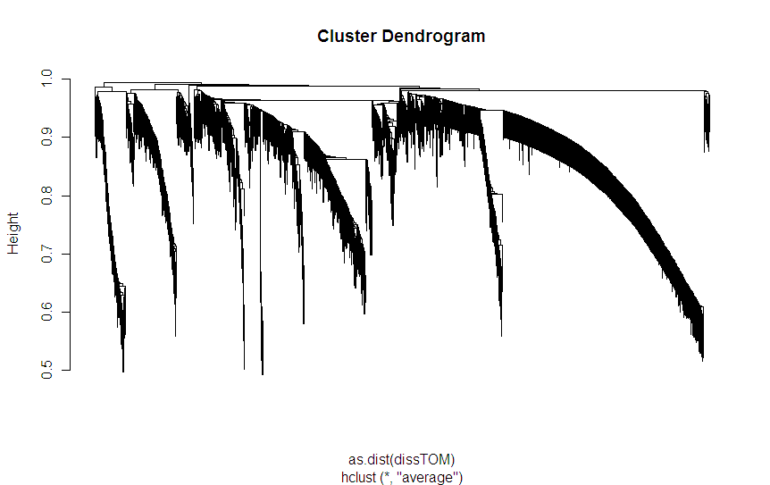

# According to our definition, modules correspond to branches of the tree.
# The question is what height cut-off should be used? This depends on the
# biology. Large heigth values lead to big modules, small values lead to small
# but tight modules.
# In reality, the user should use different thresholds to see how robust the findings are.

# The function cutreeStatistColor colors each gene by the branches that
# result from choosing a particular height cut-off.
# GREY IS RESERVED to color genes that are not part of any module.
# We only consider modules that contain at least 125 genes.

colorh1= cutreeStaticColor(hierTOM,cutHeight = 0.94, minSize = 125)
# The above should be identical to colorh1=datSummary$color1[restConnectivity]

par(mfrow=c(2,1),mar=c(2,4,1,1))
plot(hierTOM, main="Cluster Dendrogram", labels=F, xlab="", sub="");
plotColorUnderTree(hierTOM,colors=data.frame(module=colorh1))
title("Module (branch) color")
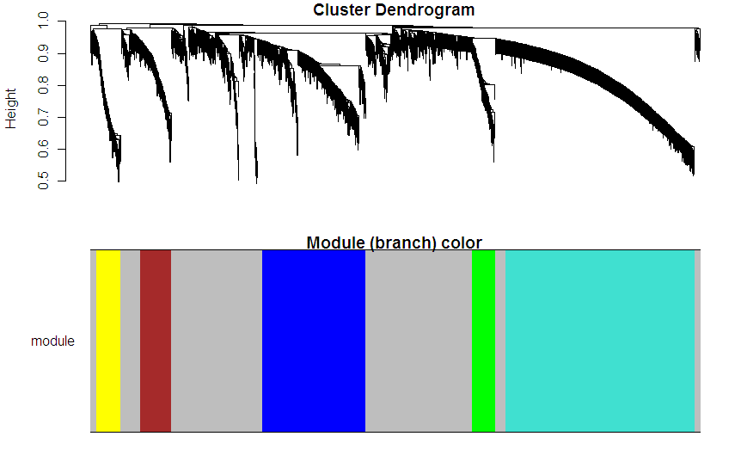
COMMENTS:
- The colors are assigned based on module size. Turquoise (others refer to it as cyan) colors the largest module, next comes blue, next brown, etc. Just type table(colorh1) to figure out which color corresponds to what module size.
- The minimum module size (minsize1=125) is unusually large. As default, we recommend minsize1=50.
- Here we choose a fixed height cut-off (h1) for cutting off branches. But we have also developed a more flexible method for cutting off branches that adaptively choose a different height for each branch. The resulting dynamic tree cutting algorithm (cutreeDynamic) is desccribed in Langfelder et al (2008).

labelDynamicTree= cutreeDynamic(hierTOM,method="tree", minClusterSize = 50)
table(labelDynamicTree)
colorDynamicTree=labels2colors(labelDynamicTree)

labelDynamicHybrid= cutreeDynamic(hierTOM, distM= dissTOM , minClusterSize = 50)
colorDynamicHybrid=labels2colors(labelDynamicHybrid)

GS=-log10(datSummary$pCox)
GScolor=numbers2colors(GS[restConnectivity],signed=T)

par(mfrow=c(2,1),mar=c(2,4,1,1))
plot(hierTOM, main="Cluster Dendrogram", labels=F, xlab="", sub="");
plotColorUnderTree(hierTOM,colors=data.frame(colorStatic=colorh1, colorDynamicTree, colorDynamicHybrid, GScolor))
title("Module (branch) color")

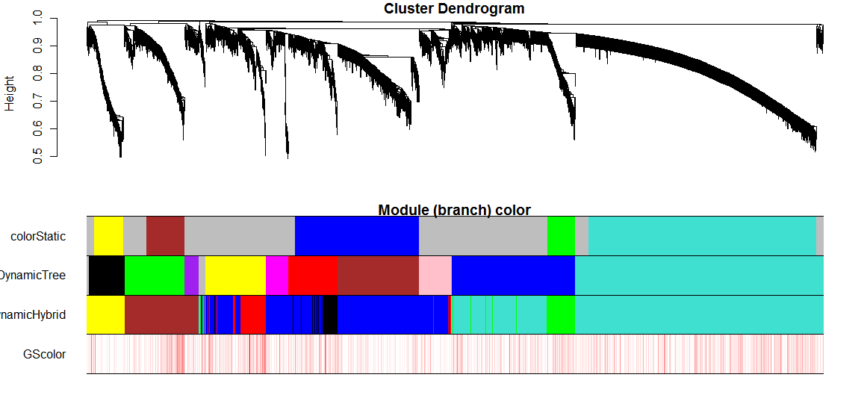

# An alternative view of this is the so called TOM plot that is generated by the
# function TOMplot
# Inputs: TOM distance measure, hierarchical (hclust) object, color

# Warning: for large gene sets, say more than 2000 genes
#this will take a while. I recommend you skip this, which is why I comment it out.
#TOMplot(dissTOM , hierTOM, colorh1)
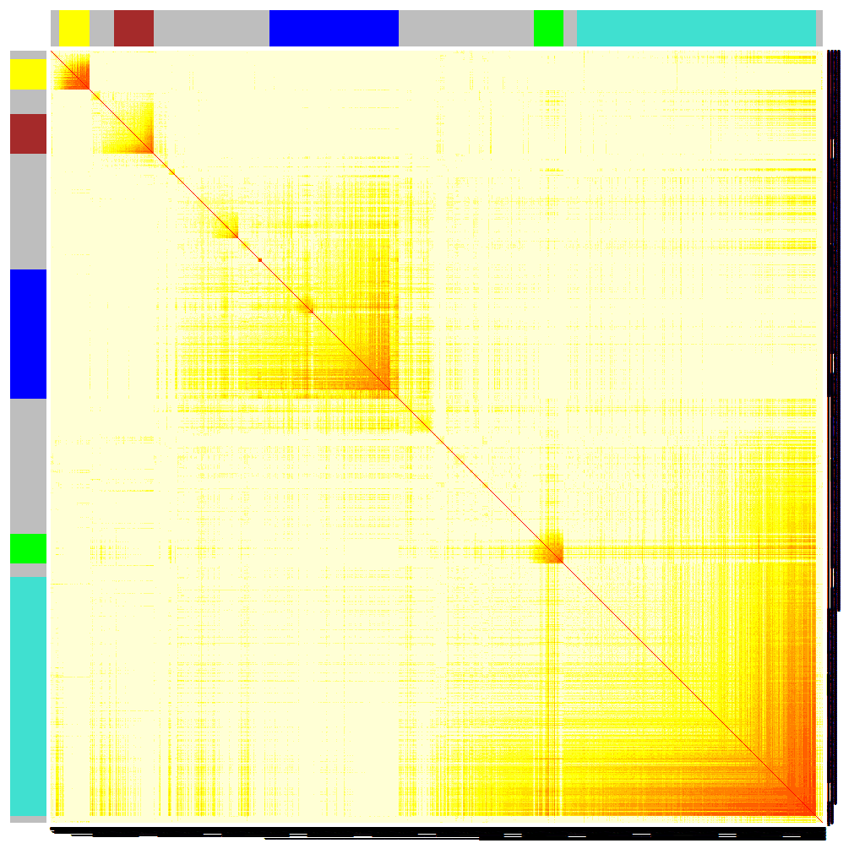

In the following proceed with the module assignment encoded in the vector colorh1. Reason: this is the module assignment we used in our original cancer publication (Horvath et al 2006). It turns out that the resulting modules had highly significant gene ontology enrichment and could be validated in the second independent data set.

# We also propose to use classical multi-dimensional scaling plots
# for visualizing the network. Here we chose 2 scaling dimensions
# This will take a few minutes.
cmd1=cmdscale(as.dist(dissTOM),2)
par(mfrow=c(1,1))
plot(cmd1, col=as.character(colorh1), main="MDS plot",xlab="Scaling Dimension 1",ylab="Scaling Dimension 2")

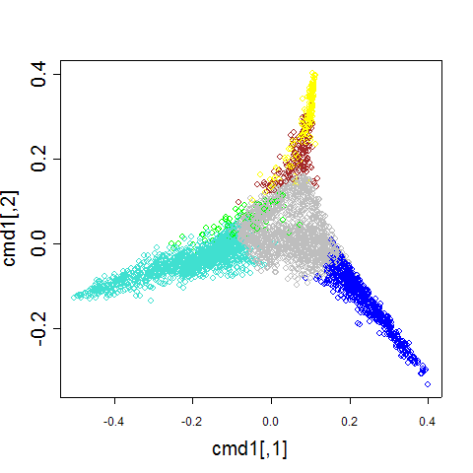

Module significance
#Next we define a gene significance variable as minus log10 of the univarite Cox regression p-value for predicting survival on the basis of the gene epxression info

# this defines the gene significance for all genes
GeneSignificanceALL=-log10(datSummary$pCox)
# gene significance restricted to the most connected genes:
GeneSignificance=GeneSignificanceALL[restConnectivity]

# The function verboseBarplot creates a bar plot
# that shows whether modules are enriched with essential genes.
# It also reports a Kruskal Wallis P-value.
# The gene significance can be a binary variable or a quantitative variable.
# also plots the 95% confidence interval of the mean
par(mfrow=c(1,1))
verboseBarplot(GeneSignificance,colorh1,main="Module Significance ",
col=levels(factor(colorh1)) ,xlab="Module" )

Note that the brown module have a high mean value of gene significance.
As aside for the experts, we should mention that the p-value (Kruskal Wallis test) cannot be trusted due to dependence between the genes. The p-value should really be interpreted as a descriptive (not inferential) measure.

# To get a sense of how related the modules are one can summarize each module
# by its first eigengene (referred to as principal components).
# and then correlate these module eigengenes with each other.

datME=moduleEigengenes(datExpr[,restConnectivity],colorh1)[[1]]

# We define a dissimilarity measure between the module eigengenes that keeps track of the sign of the correlation between the module eigengenes.
dissimME=1-(t(cor(datME, method="p")))/2

hclustdatME=hclust(as.dist(dissimME), method="average" )
par(mfrow=c(1,1))
plot(hclustdatME, main="Clustering tree based on the module eigengenes of modules")

Compare this output with the following:
signif(cor(datME, use="p"), 2)

# Now we create scatter plots of the samples (arrays) along the module eigengenes.
datMEordered=datME[,hclustdatME$order]

# before running this code, you may need to first run
# the command example(pairs) (hit returns) to read in panel.cor etc.

pairs( datMEordered, upper.panel = panel.smooth, lower.panel = panel.cor , diag.panel=panel.hist ,main="Relation between module eigengenes")

Message: the module eigengenes (first PC) of different modules may be highly correlated.
WGCNA can be interpreted as a biologically motivated data reduction scheme that allows for dependency between the resulting components. Compare this to principal component analysis that would impose orthogonality between the components.
Since modules may represent biological pathways there is no biological reason why modules should be orthogonal to each other.
Aside: If you are interested in networks comprised of module eigengenes, the following article may be of interest:
Langfelder P, Horvath S (2007) Eigengene networks for studying the relationships between co-expression modules. BMC Systems Biology 2007, 1:54
#To study how connectivity is related to mean gene expression or variance of gene expression
# we create the following plot.
mean1=function(x) mean(x,na.rm=T)
var1=function(x) var(x,na.rm=T)
meanExpr=apply( datExpr[,restConnectivity],2,mean1)
varExpr=apply( datExpr[,restConnectivity],2,var1)
par(mfrow=c(1,2))
plot(Connectivity[restConnectivity],meanExpr, col=as.character(colorh1), main="Mean(Expression) vs K",xlab="Connectivity")
plot (Connectivity[restConnectivity],varExpr, col= as.character(colorh1), main="Var(Expression) vs K" ,xlab="Connectivity")

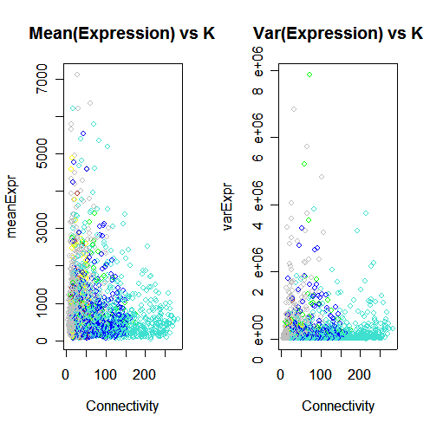
# The following produces heatmap plots for each module.
# Here the rows are genes and the columns are samples.
# Well defined modules results in characteristic band structures since the corresponding genes are
# highly correlated.

par(mfrow=c(2,1), mar=c(1, 2, 4, 1))
ClusterSamples=hclust(dist(datExpr[,restConnectivity] ),method="average")
# for the first (turquoise) module we use
which.module="turquoise"
plot.mat(t(scale(datExpr[ClusterSamples$order,restConnectivity][,colorh1==which.module ]) ),nrgcols=30,rlabels=T, clabels=T,rcols=which.module,
main=which.module )
# for the second (blue) module we use
which.module="blue"
plot.mat(t(scale(datExpr[ClusterSamples$order,restConnectivity][,colorh1==which.module ]) ),nrgcols=30,rlabels=T, clabels=T,rcols=which.module,
main=which.module )

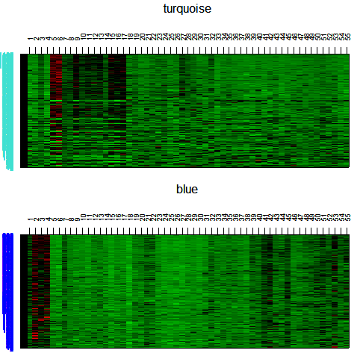

# Now we extend the color definition to all genes by coloring all non-module
# genes grey.
color1=rep("grey",dim(datExpr)[[2]])
color1[restConnectivity]=as.character(colorh1)

# The function intramodularConnectivity computes the whole network connectivity kTotal,
# the within module connectivity (kWithin). kOut=kTotal-kWithin and
# and kDiff=kIn-kOut=2*kIN-kTotal

ConnectivityMeasures=intramodularConnectivity(ADJ,colors=colorh1)
names(ConnectivityMeasures)
[1] "kTotal" "kWithin" "kOut" "kDiff"

# The following plots show the gene significance vs intramodular connectivity
colorlevels=levels(factor(colorh1))
par(mfrow=c(2,3),mar=c(5, 4, 4, 2) + 0.1)
for (i in c(1:length(colorlevels) ) ) {
whichmodule=colorlevels[[i]];restrict1=colorh1==whichmodule
verboseScatterplot(ConnectivityMeasures$kWithin[restrict1], GeneSignificance[restrict1],col=colorh1[restrict1],main= paste("set I,", whichmodule),ylab="Gene Significance",xlab="Intramodular k")
}

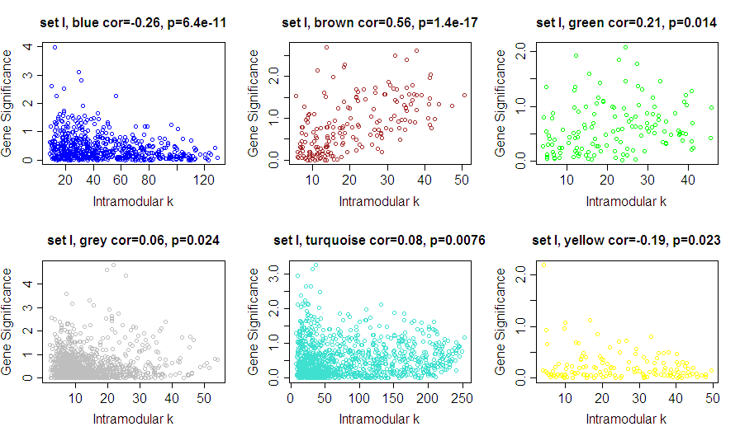

Generalizing the intramodular connectivity measure to *all* genes.
Note that the intramodular connectivity measure is only defined for the genes inside a given module. But in practice it can be very important to measure how connected a given genes is to biologically interesting modules.
Toward this end, we define a module eigengene based connectivity measure for each gene as the correlation between a the gene expression and the module eigengene.
Specifically,
kMEbrown(i)=cor(x(i), PCbrown)
where x(i) is the gene expression profile of the i-th gene and PCbrown is the module eigengene of the brown module. Note that the definition does not require that the i-th gene is a member of the brown module.

# The following data frame contains the kME values corresponding to each module.

datKME=signedKME(datExpr, datME)

#Note we have an intramodular connectivity measure for each color.

names(datKME)
[1] "kMEblue" "kMEbrown" "kMEgreen" "kMEgrey" "kMEturquoise"
[6] "kMEyellow"

# Note that the intramodular connectivity has been computed for each of the 8000 genes.

dim(datKME)
[1] 8000 6

attach(datKME)

Question: how do the kME measure relate to the standard intramodular connectivity?
whichmodule="brown"
restrictGenes= colorh1== whichmodule
par(mfrow=c(1,1))
verboseScatterplot(ConnectivityMeasures$kWithin[ restrictGenes], (datKME$kMEbrown[restConnectivity][restrictGenes])^beta1 ,xlab="kIN",ylab="kME^power", col=whichmodule,main="Relation between two measures of intramodular k, ")

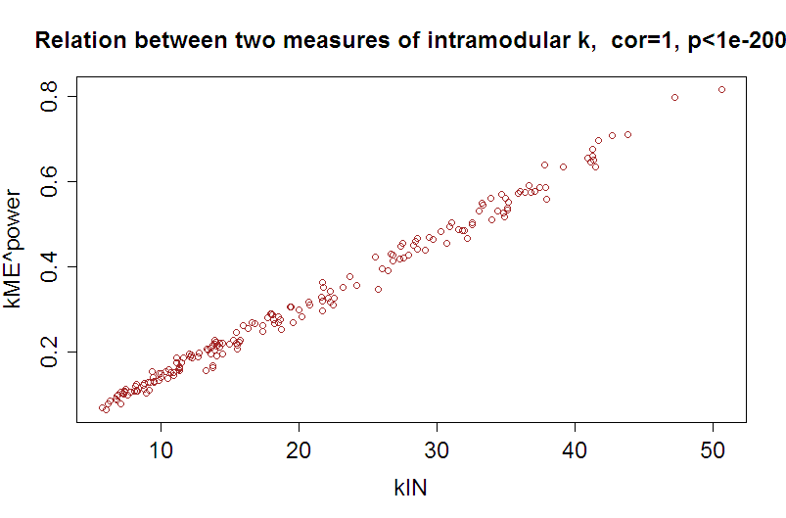
Note that after raising kME to a power of 6, it is highly correlated with kWithin. A theoretical derivation of this finding can be found in Horvath and Dong (2008).

Question: find genes with high gene significance (Cox-pvalue smaller than 0.05) and high intramodular connectivity in the brown module.

attach(datKME)
FilterGenes= GeneSignificanceALL > -log10(0.05) & abs(kMEbrown)>.85
table(FilterGenes)

datSummary[FilterGenes,]
gbm133a Gene.Symbol LocusLink pCox HazardRatio HRlower95 HRupper95 HRsd color1
731 219918_s_at ASPM 259266 0.04740 1.95 1.100 3.46 0.292 brown
805 209464_at AURKB 9212 0.04870 2.21 1.220 4.03 0.306 brown
1340 214710_s_at CCNB1 891 0.02790 1.66 0.937 2.94 0.292 brown
1402 202870_s_at CDC20 991 0.01090 2.70 1.470 4.96 0.311 brown
1404 204695_at CDC25A 993 0.04000 2.09 1.140 3.82 0.309 brown
1595 204170_s_at CKS2 1164 0.03720 1.82 1.030 3.22 0.291 brown
2297 219787_s_at ECT2 1894 0.02060 2.30 1.260 4.22 0.308 brown
2630 221591_s_at FLJ10156 54478 0.01620 1.89 1.070 3.34 0.290 brown
2671 213007_at FLJ10719 55215 0.01370 1.92 1.070 3.43 0.297 brown
2974 202580_x_at FOXM1 2305 0.02740 1.79 1.020 3.14 0.288 brown
3360 218662_s_at HCAP-G 64151 0.04670 1.70 0.957 3.02 0.293 brown
3475 208808_s_at HMGB2 3148 0.02750 1.59 0.906 2.80 0.287 brown
3921 202503_s_at KIAA0101 9768 0.02760 1.83 1.030 3.25 0.292 brown
4127 206364_at KIF14 9928 0.03340 1.81 1.020 3.20 0.292 brown
4132 218755_at KIF20A 10112 0.03750 1.81 1.020 3.20 0.292 brown
4138 218355_at KIF4A 24137 0.04720 2.52 1.380 4.61 0.307 brown
4158 218883_s_at KLIP1 79682 0.02780 1.73 0.975 3.07 0.293 brown
4164 219306_at KNSL7 56992 0.01630 2.25 1.250 4.05 0.299 brown
4166 204162_at KNTC2 10403 0.02420 1.82 1.030 3.24 0.292 brown
4168 201088_at KPNA2 3838 0.02050 2.19 1.210 3.97 0.303 brown
4481 203362_s_at MAD2L1 4085 0.02710 1.57 0.895 2.75 0.286 brown
5245 218039_at NUSAP1 51203 0.01880 1.84 1.040 3.27 0.293 brown
5826 218009_s_at PRC1 9055 0.00247 2.41 1.320 4.41 0.307 brown
6010 203554_x_at PTTG1 9232 0.00413 1.97 1.110 3.49 0.292 brown
6012 208511_at PTTG2 10744 0.03050 1.60 0.901 2.84 0.293 brown
6437 201890_at RRM2 6241 0.01840 1.75 0.982 3.13 0.296 brown
7450 201292_at TOP2A 7153 0.02810 1.92 1.080 3.41 0.292 brown
7453 219148_at TOPK 55872 0.01930 2.00 1.130 3.54 0.291 brown
7481 210052_s_at TPX2 22974 0.00918 1.89 1.070 3.35 0.291 brown
7624 202954_at UBE2C 11065 0.00321 2.09 1.150 3.80 0.306 brown

Comments:
The ASPM gene colored in red was the focus of the paper Horvath et al (2006) but there are many other interesting genes.

To illustrate the use of the kME measures, we also address the following questions

Question: Screen for significant genes that have a negative correlation with the brown module eigengene
FilterGenes= GeneSignificanceALL> -log10(0.05) & -kMEbrown> .5 # notice the red minus sign!
table(FilterGenes)
datSummary[FilterGenes,]
gbm133a Gene.Symbol LocusLink pCox HazardRatio HRlower95 HRupper95 HRsd color1
561 206200_s_at ANXA11 311 0.0132 1.69 0.967 2.97 0.286 grey
1618 221042_s_at CLMN 79789 0.0257 1.60 0.906 2.81 0.288 green
5567 214152_at PIGB 9488 0.0396 1.55 0.884 2.71 0.286 turquoise
6682 201811_x_at SH3BP5 9467 0.0162 2.09 1.180 3.69 0.290 turquoise

Question: Screen for significant genes that are close to the brown module and the green module and far away from the yellow module. Answer
FilterGenes= GeneSignificanceALL > -log10(0.05) & abs(kMEbrown)>.5 & abs(kMEgreen)>.5
table(FilterGenes)
datSummary[FilterGenes,]
gbm133a Gene.Symbol LocusLink pCox HazardRatio HRlower95 HRupper95 HRsd color1
1422 218399_s_at CDCA4 55038 0.0438 1.25 0.716 2.18 0.284 turquoise
1618 221042_s_at CLMN 79789 0.0257 1.60 0.906 2.81 0.288 green
3244 213170_at GPX7 2882 0.0199 1.09 0.626 1.91 0.285 grey
6682 201811_x_at SH3BP5 9467 0.0162 2.09 1.180 3.69 0.290 turquoise

Question: Screen for significant genes that are close to the brown module and far away from the yellow module. Answer
FilterGenes= GeneSignificanceALL > -log10(0.05) & abs(kMEbrown)>.6 & abs(kMEyellow)<.3
table(FilterGenes)

How to output the data?

datout=data.frame(datSummary, colorNEW=color1, ConnectivityNew=Connectivity,datKME )
write.table(datout, file="OutputCancerNetwork.csv", sep=",", row.names=F)
# The file can now be found in your current working directory (see the setwd command above).
This file should be sent to your clinical collaborators so that they can study the resulting gene list.

Next logical step: carry out a functional enrichment analysis of each module.

For example, input all genes with abs(kMEbrown)>0.8 into

EASE (David)
http://david.abcc.ncifcrf.gov/summary.jsp

The WGCNA library also contains several functions for gene ontology information (e.g. the function GOenrichmentAnalysis) as you can learn from help(WGCNA)
THE END: To cite the code and methods in this manual, please use
Bin Zhang and Steve Horvath (2005) "A General Framework for Weighted Gene Co-Expression Network Analysis", Statistical Applications in Genetics and Molecular Biology: Vol. 4: No. 1, Article 17

